**Basic Electronics**

**Course Code GE101**

**Lab 3 Manual**



**Introduction to Resistors**

**Color Coding**

**Measuring with DMM**

**Department of Computer Science**

**University of Central Punjab**

**Objective:**

* To learn the basic electrical component resistor and their types.
* To learn the color coding of resistor and also by using DMM

**Equipment:**

Resistors, Bread Board, DMM

**Outcome:**

* After this lab, students will be able to measure the resistance by color coding and their range.
* Students will know how to use it to measure resistance of resistor by using DMM.
* Students will know different type of resistors and resistive sensors

**Resistor**

A component that is spe

cifically designed to have a certain

amount of resistance is called a

resistor. The principal

applications of resistors are to limit current in a circuit, to divide

voltage, and, in certain cases, to generate heat. Although resistors

come in many shapes an

d

sizes, they can all be placed in one of two main categories: fixed

or variable.

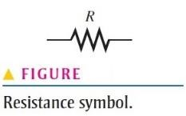

**Fixed Resistors**

Fixed resistors are available with a large selection of resistance values that are set during manufacturing and cannot be changed easily. They are constructed using various methods and materials.

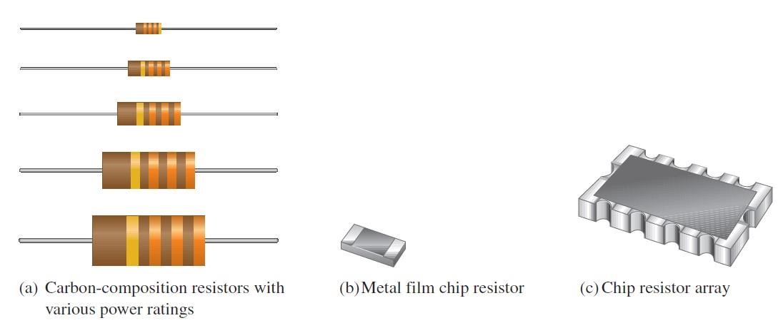

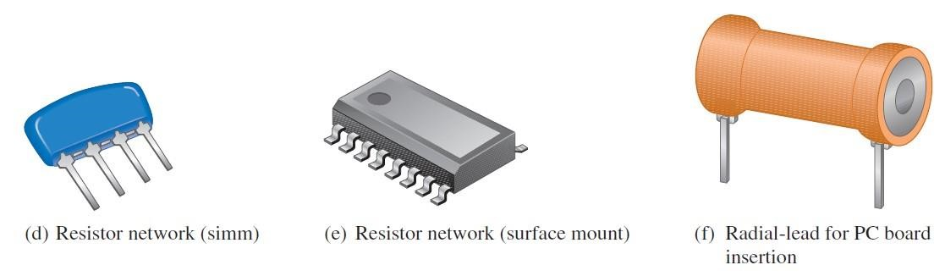

One common fixed resistor is the carbon-composition type, which is made with a mixture of finely ground carbon, insulating filler, and a resin binder. The ratio of carbon to insulating filler sets the resistance value. The mixture is formed into rods, and conductive lead connections are made. The entire resistor is then encapsulated in an insulated coating for protection. Figure shows the construction of a typical carbon-composition resistor.

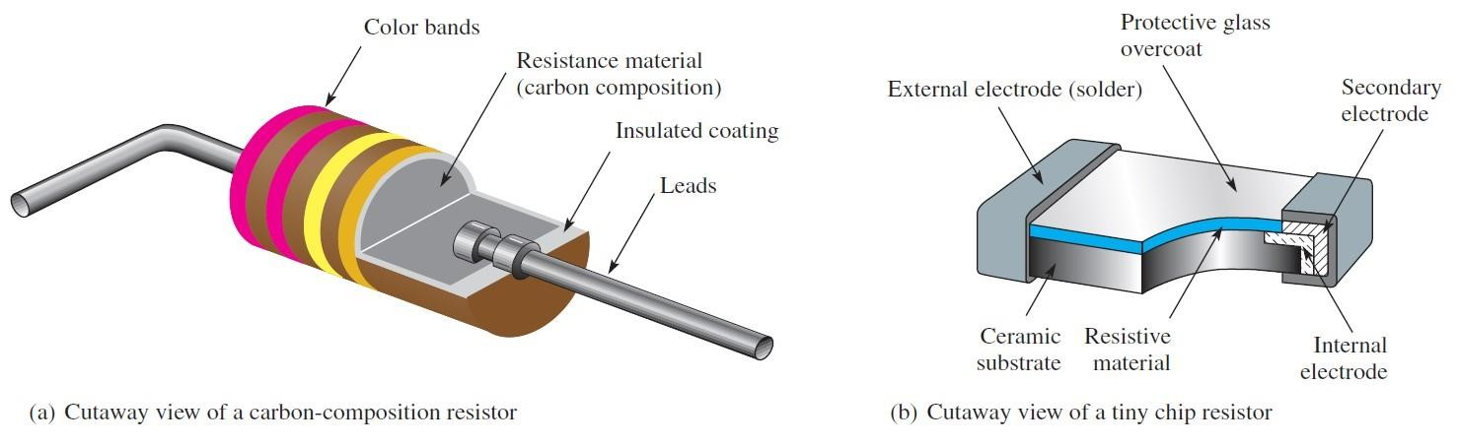

The chip resistor is another type of fixed resistor and is in the category of SMT (surface mount technology) components. It has the advantage of a very small size for compact assemblies. Figure shows the construction of a chip resistor.

Other types of fixed resistors include carbon film, metal film, and wire wound. In film resistors, a resistive material is deposited evenly onto a high-grade ceramic rod. The resistive film may be carbon (carbon film) or nickel chromium (metal film). In these types of resistors, the desired resistance value is obtained by removing part of the resistive material in a helical pattern along the rod using a spiralling technique, as shown in Figure. Very close **tolerance** can be achieved with this method. Film resistors are also available in the form of resistor networks, as shown in Figure.

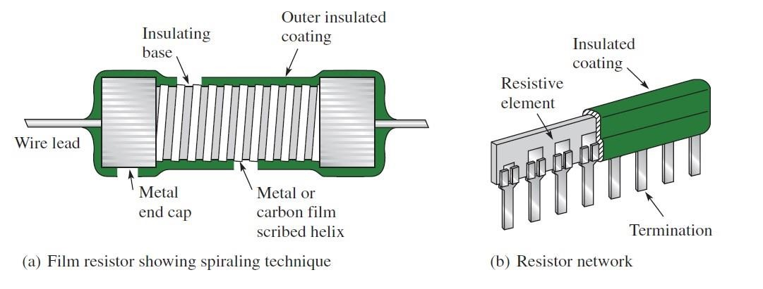

Wirewound resistors are constructed with resistive wire wound around an insulating rod and then sealed. Normally, wirewound resistors are used in applications that require higher power ratings. Since they are constructed with a coil of wire, wirewound resistors have significant inductance and are not used at higher frequencies. Some typical wirewound resistors are shown in Figure.

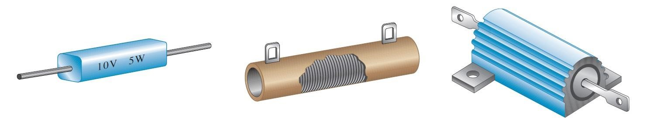

**Variable resistors**

Variable resistors are designed so that their resistance values can be changed easily. Two basic uses for variable resistors are to divide voltage and to control current. The variable resistor used to divide voltage is called a potentiometer. The variable resistor used to control current is called a rheostat. Schematic symbols for these types are shown in Figure. The potentiometer is a three-terminal device, as indicated in part (a). Terminals 1 and 2 have a fixed resistance between them, which is the total resistance. Terminal 3 is connected

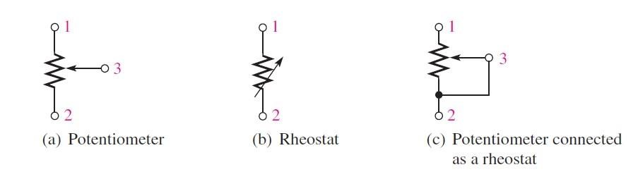

to a moving contact (wiper). You can vary the resistance between 3 and 1 or between 3

and 2 by moving the contact.

Figure (b) shows the rheostat as a two-terminal variable resistor. Part (c) shows how you can use a potentiometer as a rheostat by connecting terminal 3 to either terminal 1 or

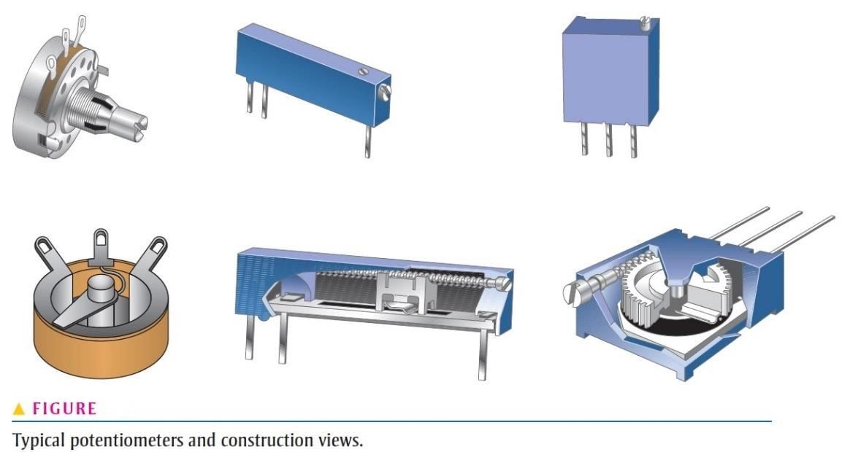

terminal 2. Parts (b) and (c) are equivalent symbols. Some typical potentiometers are pictured in Figure.

Potentiometers and rheostats can be classified as linear or tapered, as shown in Figure, where a potentiometer with a total resistance of is used as an example. As shown in part (a), in a linear potentiometer, the resistance between either terminal and the moving contact varies linearly with the position of the moving contact. For example, one-half of the total contact movement results in one-half the total resistance. Three-quarters of the total movement results in three-quarters of the total resistance between the moving contact and one terminal, or one-quarter of the total resistance between the other terminal and the moving contact. In the **tapered** potentiometer, the resistance varies nonlinearly with the position of the moving contact, so that one-half of a turn does not necessarily result in onehalf the total resistance. This concept is illustrated in Figure (b), where the nonlinear values are arbitrary. The potentiometer is used as a voltage-control device because when a fixed voltage is applied across the end terminals, a variable voltage is obtained at the wiper contact with respect to either end terminal. The rheostat is used as a current-control device because the current can be changed by changing the wiper position.

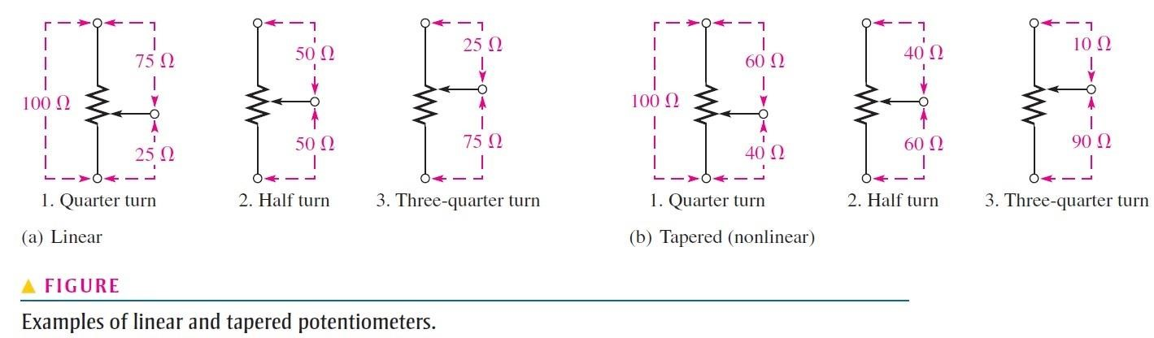

**Variable Resistance Sensors**

Many sensors operate on the concept of a variable resistance, in which a physical quantity alters the electrical resistance. Depending on the sensor and the measurement requirements, the change in resistance may be determined directly or indirectly using the resistance change to alter a voltage or current.

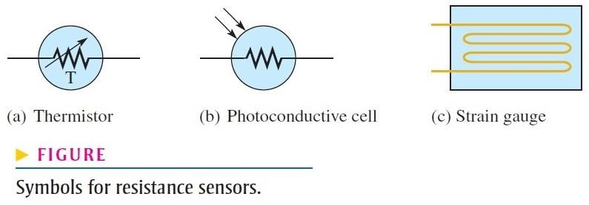Examples of resistance sensors include **thermistors** that change resistance as a function of temperature, **photoconductive cells** that change resistance as a function of light, and strain gauges that change resistance when a force is applied to them. Strain gauges are widely used in scales and applications where mechanical motion needs to be sensed. The measuring instruments need to be very sensitive because the change in resistance is very small. Figure shows symbols for these various resistance sensors.

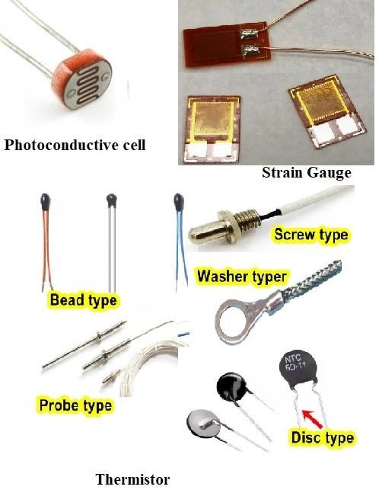

**Resistance Through Color Coding**

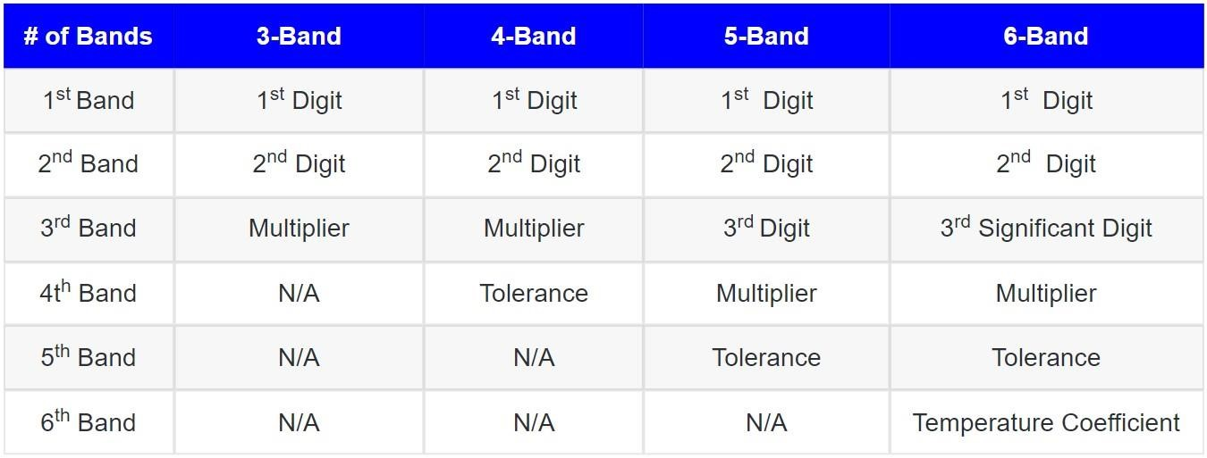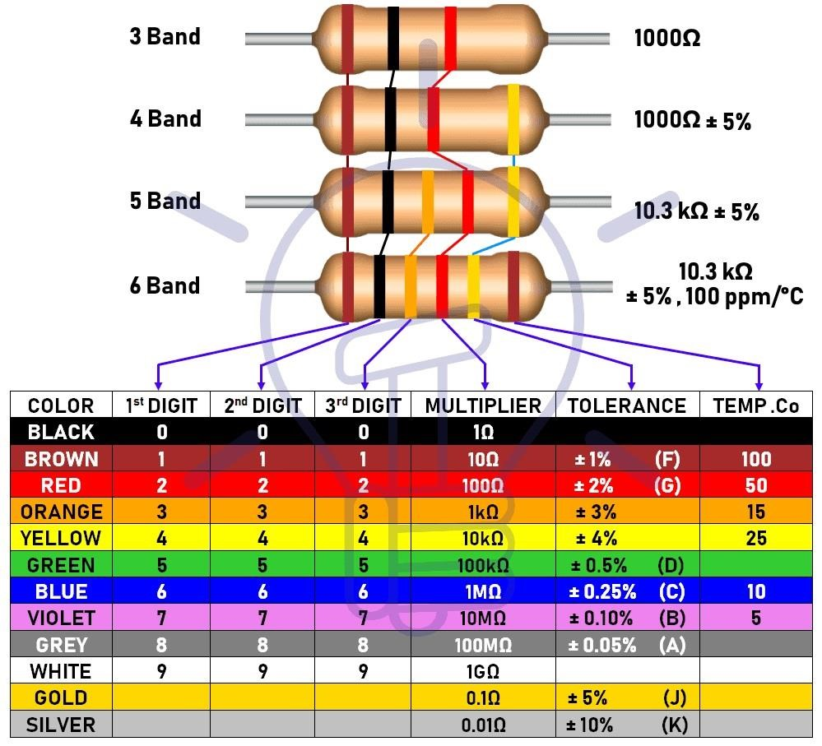

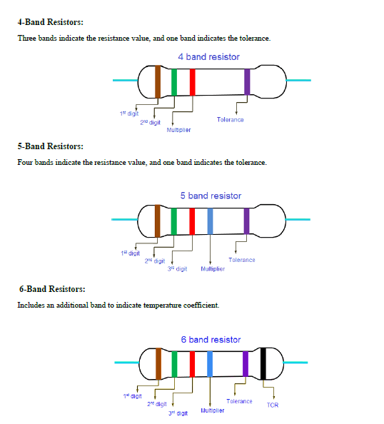

**Range of Resistance**

The range of resistance means the percentage of error present in a resistor or the minimum to the maximum of resistance that a resistor can offer.

The range of resistance is actually calculated from the percentage of Tolerance given for the resistor. Mostly for tolerance, golden and silver colors are used having tolerances of 5% and 10% respectively.

For Example

Find out the range (maximum and minimum value) of resistance of the following resistor.

• **3.3 KΩ ± 5%**

**Solution**

**Step 1:**

**Find the percentage factor**

Percentage factor = resistance value * tolerance

Percentage factor 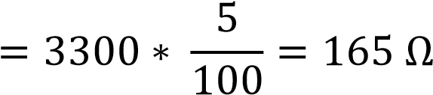

**Step 2:**

**Find the minimum value**

Minimum value = Resistance value – Percentage factor

= 3300 - 165 = 3135 Ω

**Step 3:**

**Find the maximum value**

Maximum value = Resistance value + Percentage factor

= 3300 + 165 = 3465 Ω

**Hence, the range of the resistance for the given resistor is 3135 Ω to 3465 Ω Resistor Label Codes**

Not all types of resistors are color coded. Many, including surface- mount resistors, use typographical marking to indicate the resistance value and tolerance. These label codes consist of either all numbers (numeric) or a combination of numbers and letters (alphanumeric). In some cases when the body of the resistor is large enough, the entire resistance value and tolerance are stamped on it in standard form. Numeric labeling uses three digits to indicate the resistance value, as shown in Figure using a specific example. The first two digits give the first two digits of the resistance value, and the third digit gives the multiplier or number of zeros that follow the first two digits. This code is limited to values of 10 Ω or greater.

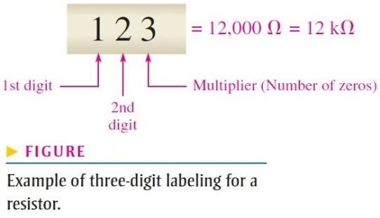

Another common type of marking is a three- or four-character label that uses both digits and letters. An alphanumeric label typically consists of only three digits or two or three digits and one of the letters R, K, or M. The letter is used to indicate the multiplier, and the position of the letter indicates the decimal point placement. The letter R indicates a multiplier of 1 (no zeros after the digits), the K indicates a multiplier of 1000 (three zeros after the digits), and the M indicates a multiplier of 1,000,000 (six zeros after the digits). In this format, values from 100 to 999 consist of three digits and no letter to represent the three digits in the resistance value. Figure 32 shows three examples of this type of resistor label.

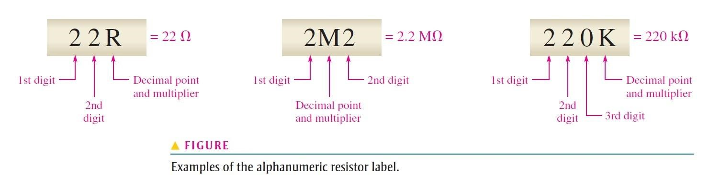

DC Measurements

Measurement of Voltage, Current and Resistance using Digital Multimeter (DMM)

Equipment:

1. Digital Multimeter (DMM)
2. Battery Pack and Batteries
3. LEDs
4. Breadboard
5. Resistors
6. Jumper wires

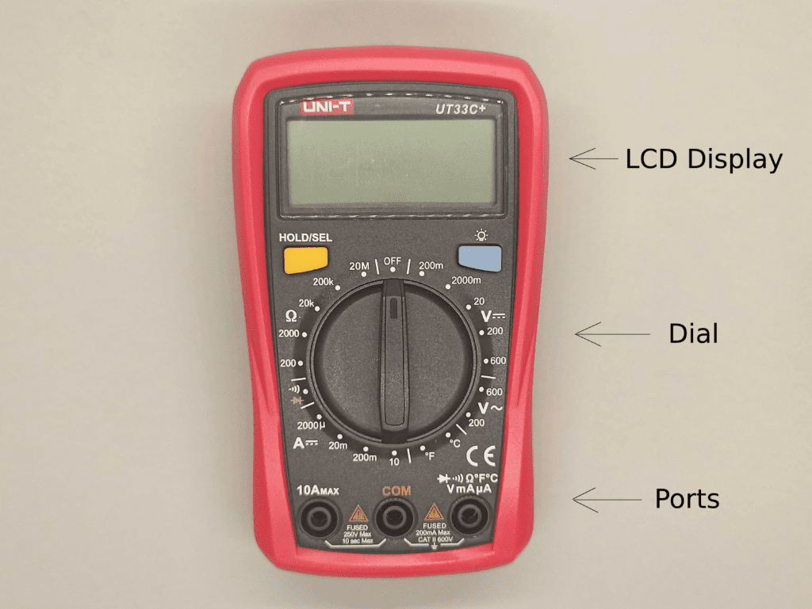

**How To Setup a Multimeter to Measure Volts, Amps or Ohms**

Voltage, current and resistance ranges are usually set by turning a rotary range selection switch. This is set to the quantity being measured, e.g. AC volts, DC volts, Amps(current) or Ohms (resistance). Each function will have several ranges. So for example, the DC volts function range will typically have 1000V, 200V , 20V, 2V and 200mV ranges. Using the lowest range possible gives more significant figures in the reading.

**Part 01: How to Measure Voltage using DMM**

1. Plug the black (ground) probe lead into the **COM** port and red (positive) probe lead into the port marked **mAVΩ**. Connect the probe leads as shown in the picture below.
2. If the meter has a manual range selection dial, turn this to select DC volts and pick a range slightly higher than the expected voltage value. The number you see on the dial is the highest value you can measure with that range. So, if you set the dial to 20, then you can measure DC Voltages up to 20V.
3. Connect the multimeter in parallel with the voltage source, load or any other two points across which voltage needs to be measured. Touch the black probe against the first point and red probe against the second point of the circuit. As shown in the picture below.
4. Take the reading on the LCD display. If the reading is zero or too small, switch to a lower range to get a more accurate reading. If the LCD displays 1 or OL, its overloaded, indicating that the result has exceeded the range, switch to a next higher range value.

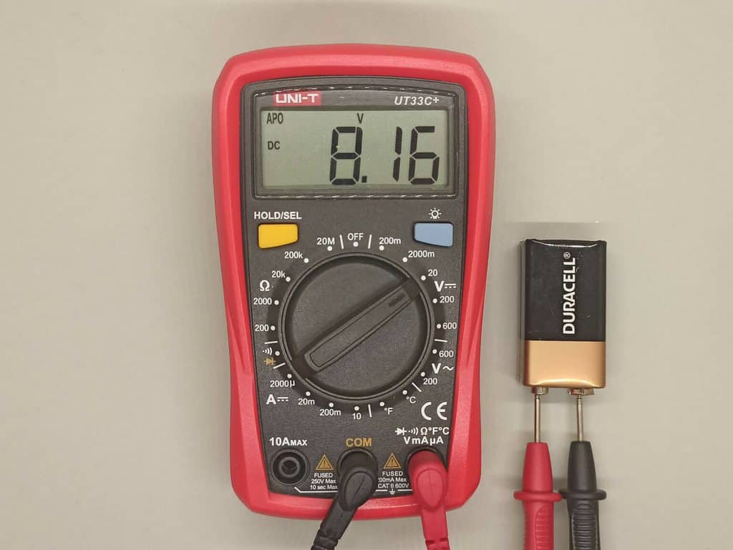

DMM Connected in parallel with a battery to measure voltage across it.

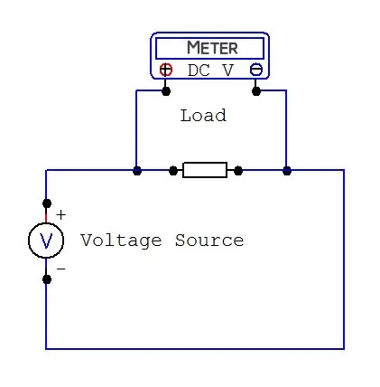

DMM connected in parallel with load to measure voltage across it.

**Part 02: How to Measure Current using DMM**

1. Plug the black (ground) probe lead into the COM socket and red (positive) probe lead either into the **mAVΩ** socket or the high current socket which is usually marked 10A, respectively.
2. If the meter has a manual range selection dial, turn this to select DC current and pick a range slightly higher than the expected current value. The number you see on the dial is the highest value you can measure with that range. So, if you set the dial to 200mA, then you can measure DC current up to 200mA. If you estimate that the current will be greater than this value, you must use the 10 A socket, otherwise you will end up blowing a fuse in the meter.
3. Connect the DMM in series with the component across which current needs to be measured. See the diagram below.
4. 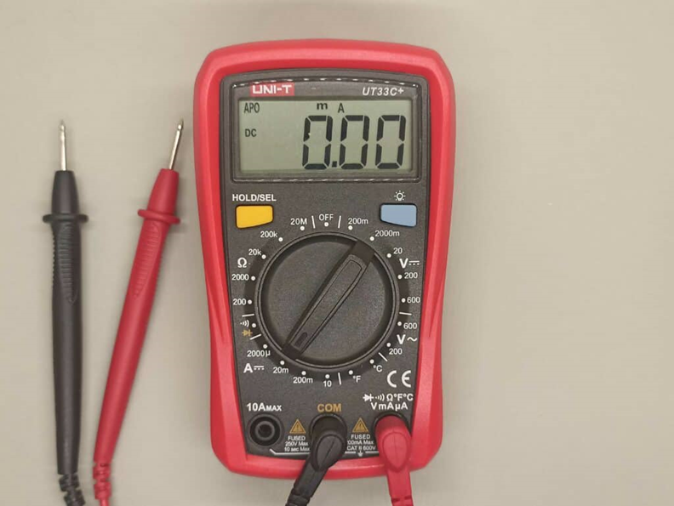Take the reading on the LCD display. If the reading is zero or too small, switch to a lower range to get a more accurate reading. If the LCD displays 1 or OL, its overloaded, indicating that the result has exceeded the range, switch to a next higher range value.

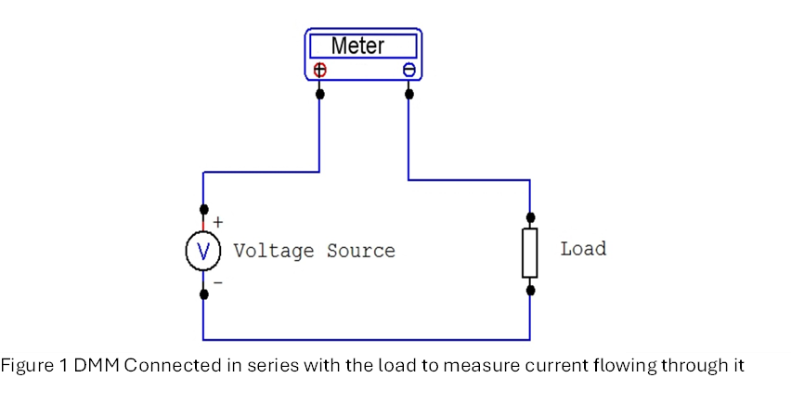

DMM Connected in series with the resistor to measure current flowing through it.

**Part 03: How to Measure Resistance using DMM**

1. Connect the black probe to the COM port and the red probe to the port marked with mAVΩ.
2. Select the resistance option marked OHM Ω on the dial and choose the range you think your resistor is within. The number you see on the dial is the highest value you can measure with that range.
3. Note that if you want to measure the resistance of a resistor, you need to remove it from the circuit. Otherwise, the other components in the circuit can influence the reading.
4. To measure resistance, simply place the probes across the resistor, as shown in the picture
5. 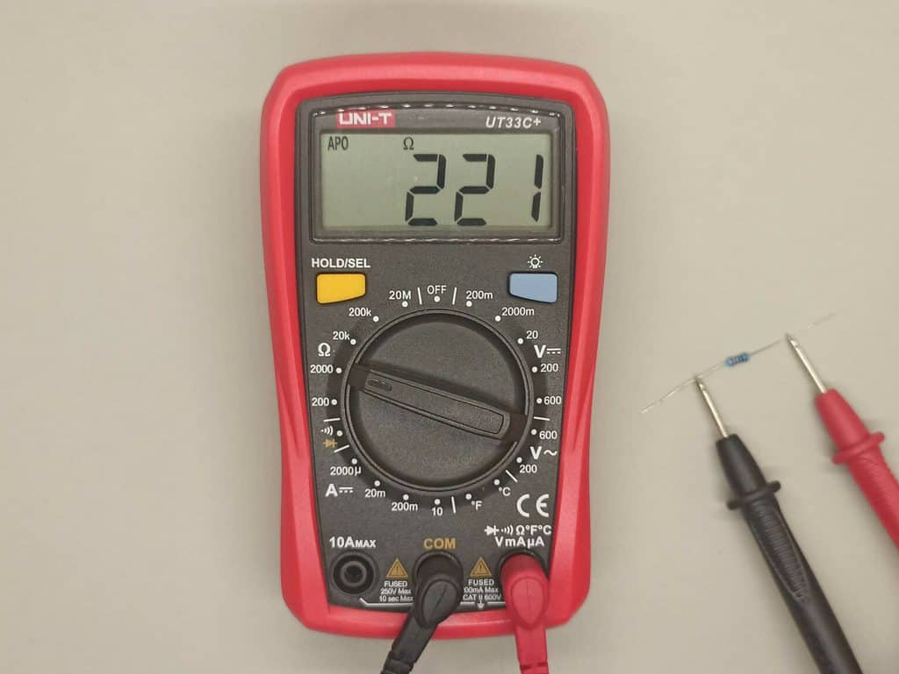Take the reading on the LCD display. If the reading is zero or too small, switch to a lower range to get a more accurate reading. If the LCD displays 1 or OL, its overloaded, indicating that the result has exceeded the range, switch to a next higher range value.

**How To Connect a Light-Emitting Diode**

An LED has two pins – *anode*and *cathode*:

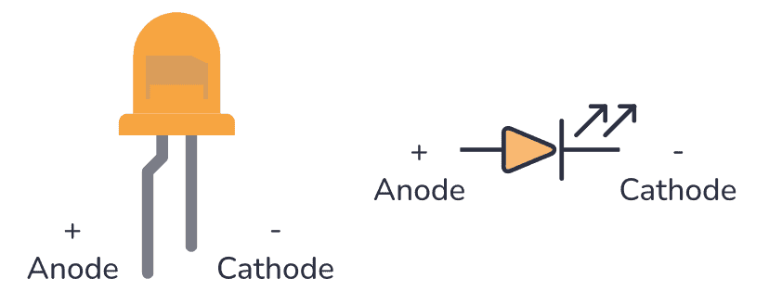

The anode is the longest pin. This is the pin you connect to the most positive voltage. The cathode is the pin you connect to the most negative voltage.

They must be connected correctly for the LED to work. If you connect them in the opposite direction no current will flow, just as with standard diodes.

In addition to connecting the LED with the correct orientation, it’s important to connect it in series with a resistor to limit its current. A resistor connecting in series with an LED is called a current-limiting resistor.

**Simple LED Circuit Example:**

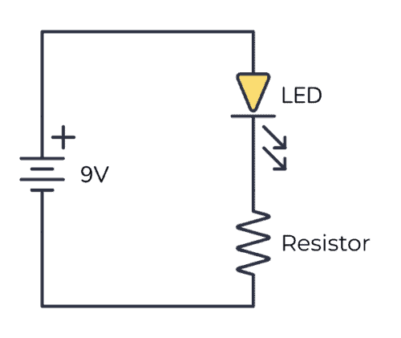Here’s a simple example of how to connect a light-emitting diode in a circuit.

Usually, an LED needs about 2-3 volts and about 1-10 mA to light up. But this varies among different LED types. The easiest way to find this information is to look it up in the datasheet (look for *LED forward voltage* and *Test Current*) – or ask the store where you bought it.

You don’t have to worry too much about the voltage. For most standard LEDs, if you have a voltage of around 9V and use a resistor in series of around 1 kΩ to 10 kΩ, the LED will “grab” the voltage it needs.

If you run too much current through an LED, it will get really hot and break down. That’s why the resistor is there – to control how much current that goes through the LED. The only time you don’t need the resistor is when you have a battery or other voltage source that provides exactly the voltage your LED needs.

**Measuring Resistance through DMM**

To measure resistance, first turn off the power and disconnect one end or both ends of the resistor from the circuit; then connect the DMM across the resistor. This procedure is shown in Figure.

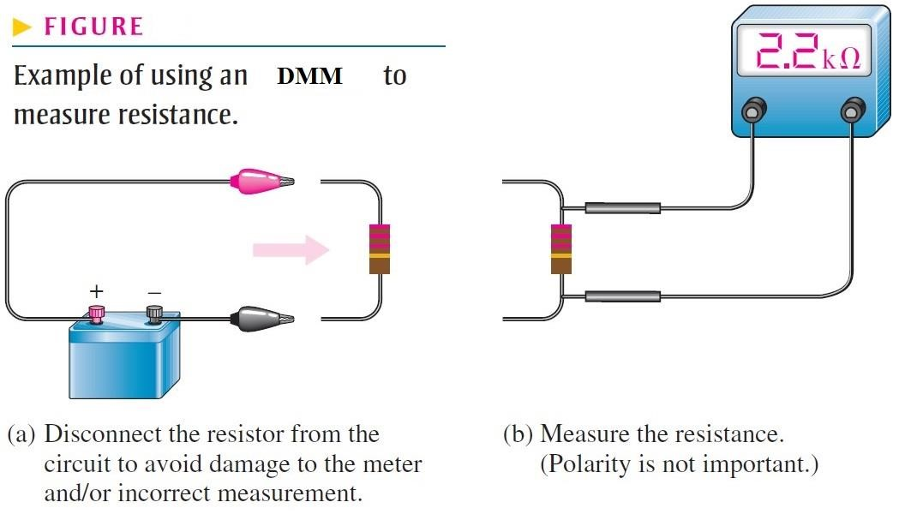

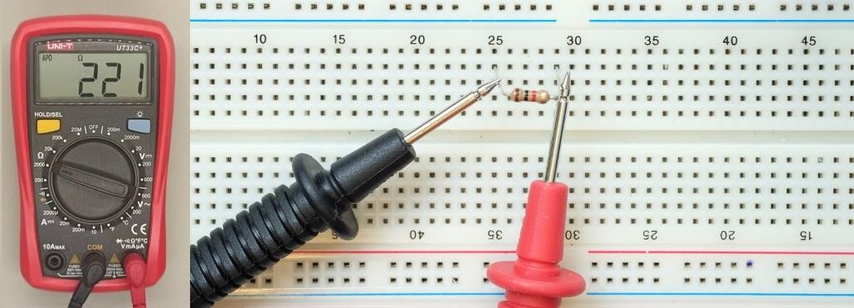

**Lab Task 1**

|  |  |  |  |  |  |  |
| --- | --- | --- | --- | --- | --- | --- |
| Resistor 1 |  | Colour value | Resistance by Colour | maximum value | Minimum value | Resistance by DMM |
| 1st Colour |  |  |  |  |  |  |
| 2nd Colour |  |  |
| 3rd Colour |  |  |
| 4th Colour |  |  |
| 5th Colour |  |  |
| 6th Colour |  |  |

|  |  |  |  |  |  |  |
| --- | --- | --- | --- | --- | --- | --- |
| Resistor 2 |  | Colour value | Resistance by Colour | maximum value | Minimum value | Resistance by DMM |
| 1st Colour |  |  |  |  |  |  |
| 2nd Colour |  |  |
| 3rd Colour |  |  |
| 4th Colour |  |  |
| 5th Colour |  |  |
| 6th Colour |  |  |

|  |  |  |  |  |  |  |
| --- | --- | --- | --- | --- | --- | --- |
| Resistor 3 |  | Colour value | Resistance by Colour | maximum value | Minimum value | Resistance by DMM |
| 1st Colour |  |  |  |  |  |  |
| 2nd Colour |  |  |
| 3rd Colour |  |  |
| 4th Colour |  |  |
| 5th Colour |  |  |
| 6th Colour |  |  |

|  |  |  |  |  |  |  |
| --- | --- | --- | --- | --- | --- | --- |
| Resistor 4 |  | Colour value | Resistance by Colour | maximum value | Minimum value | Resistance by DMM |
| 1st Colour |  |  |  |  |  |  |
| 2nd Colour |  |  |
| 3rd Colour |  |  |
| 4th Colour |  |  |
| 5th Colour |  |  |
| 6th Colour |  |  |

|  |  |  |  |  |  |  |
| --- | --- | --- | --- | --- | --- | --- |
| Resistor 5 |  | Colour value | Resistance by Colour | maximum value | Minimum value | Resistance by DMM |
| 1st Colour |  |  |  |  |  |  |
| 2nd Colour |  |  |
| 3rd Colour |  |  |
| 4th Colour |  |  |
| 5th Colour |  |  |
| 6th Colour |  |  |

|  |  |  |  |  |  |  |
| --- | --- | --- | --- | --- | --- | --- |
| Resistor 6 |  | Colour value | Resistance by Colour | maximum value | Minimum value | Resistance by DMM |
| 1st Colour |  |  |  |  |  |  |
| 2nd Colour |  |  |
| 3rd Colour |  |  |
| 4th Colour |  |  |
| 5th Colour |  |  |
| 6th Colour |  |  |

|  |  |  |  |  |  |  |
| --- | --- | --- | --- | --- | --- | --- |
| Resistor 7 |  | Colour value | Resistance by Colour | maximum value | Minimum value | Resistance by DMM |
| 1st Colour |  |  |  |  |  |  |
| 2nd Colour |  |  |
| 3rd Colour |  |  |
| 4th Colour |  |  |
| 5th Colour |  |  |
| 6th Colour |  |  |  |  |  |  |

|  |  |  |  |  |  |  |
| --- | --- | --- | --- | --- | --- | --- |
| Resistor 8 |  | Colour value | Resistance by Colour | maximum value | Minimum value | Resistance by DMM |
| 1st Colour |  |  |  |  |  |  |
| 2nd Colour |  |  |
| 3rd Colour |  |  |
| 4th Colour |  |  |
| 5th Colour |  |  |
| 6th Colour |  |  |

|  |  |  |  |  |  |  |
| --- | --- | --- | --- | --- | --- | --- |
| Resistor 9 |  | Colour value | Resistance by Colour | maximum value | Minimum value | Resistance by DMM |
| 1st Colour |  |  |  |  |  |  |
| 2nd Colour |  |  |
| 3rd Colour |  |  |
| 4th Colour |  |  |
| 5th Colour |  |  |
| 6th Colour |  |  |

|  |  |  |  |  |  |  |
| --- | --- | --- | --- | --- | --- | --- |
| Resistor 10 |  | Colour value | Resistance by Colour | maximum value | Minimum value | Resistance by DMM |
| 1st Colour |  |  |  |  |  |  |
| 2nd Colour |  |  |
| 3rd Colour |  |  |
| 4th Colour |  |  |
| 5th Colour |  |  |
| 6th Colour |  |  |

**Lab Task 2**

**Build a simple circuit using a 4-band resistor on the breadboard. Measure the voltage drop across the resistor using the DMM and simulate the same circuit on Tinker Cad. Compare the physical and virtual results.**

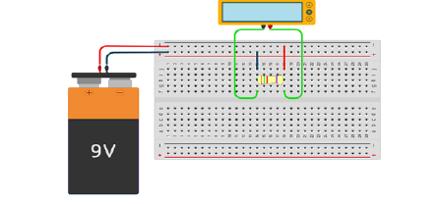

**Lab Task 3**

**Design a circuit using a 5-band resistor and a 9V battery. Measure the current through the resistor using the DMM and simulate the same circuit on Tinker Cad.**

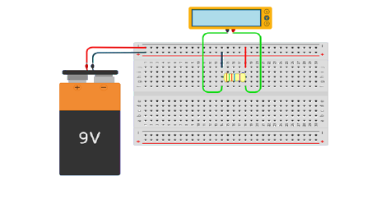

**Lab Task 4**

**Build a circuit using a 6-band resistor on the breadboard. Measure its voltage and current using the DMM, and simulate the same circuit on Tinker Cad.**

